**Practical 1**

**IT549 - Deep Learning**

**Gradient Descent**

* **Dataset**
  + - **User Dataset -** This dataset contains information on users from companies' databases. It contains information about UserID, Gender, Age, Estimated Salary, and Purchased.
    - **50_Startups -** This dataset collected data from New York, California, and Florida about 50 business Startups. The variables used in the dataset are Profit, R&D spending, Administration Spending, and Marketing Spending**.**
* **Tasks to perform** 
  + - **Code your own functions for Gradient descent, and Multiple linear regression**
      * **Load the dataset and define input features and the target variable.**
      * **Define the cost function to calculate the error**
      * **For each iteration, calculate the Hypothesis Value and difference from the actual value**
      * **Calculate the gradient and update the parameters' values (theta values).**
      * **Calculate the cost function and save the value.**
    - **Draw the contour plot considering the theta values and cost for each iteration.**

**An example of such a contour plot is given below -**

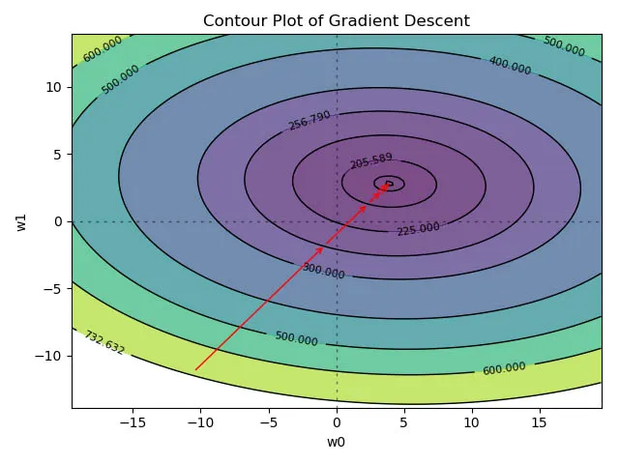

* + - **Experiment with different learning rates while updating the theta values and analyze how the contour plot changes.**
    - **Use a python library (such as sklearn) to perform all these tasks.**
    - **Use the User database and predict whether a user will purchase the company’s newly launched product or not.**
    - **Predict the profit values on the 50_startups dataset for each company.**